A guide to the rights of disabled asylum seekers, refugees and people who can no longer stay in the UK
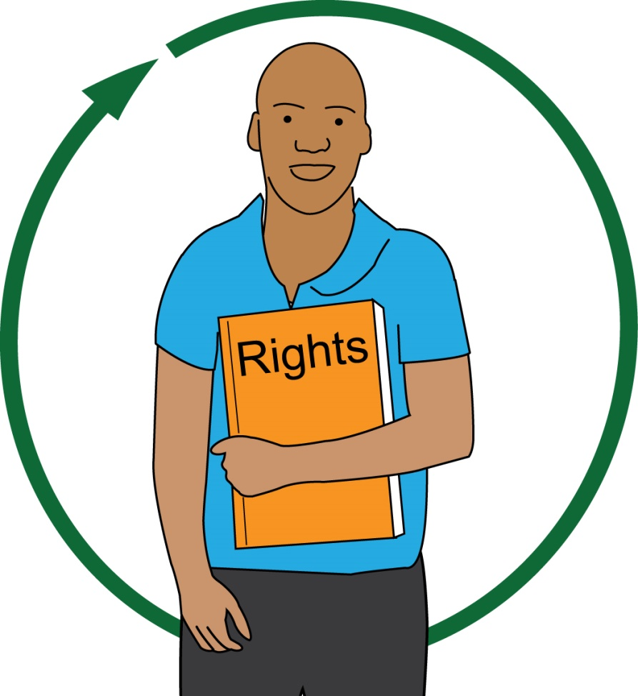

Disabled Asylum Seekers and Refugees
Asylum Seeker: this is a person who has asked the UK government to let them come to the UK so that they can be safe. However, they are still waiting for an answer from the government.
Refugee: this is a person who has been told by the government that they can stay in the UK for as long as they need to. This is for their safety.

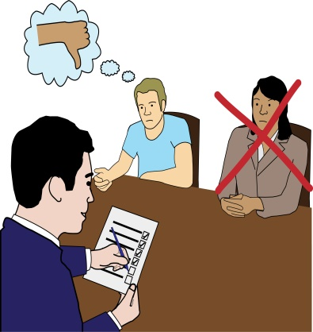
Asylum seekers and refugees sometimes do not get the right support for physical impairments and mental health needs. Some disabled asylum seekers, refugees, as well as organisations that run services, think that people can’t get support. This is not true.
Physical impairment: this affects the way that a person can move and get around.

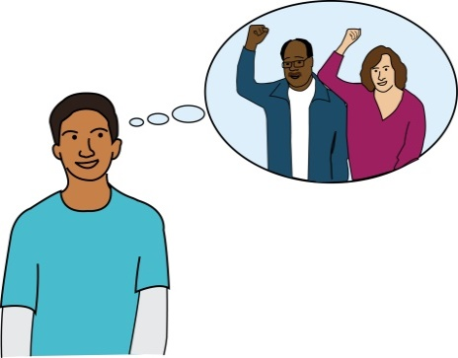
Many refugees are disabled people. This means that they have extra rights.
Disabled people can mean:
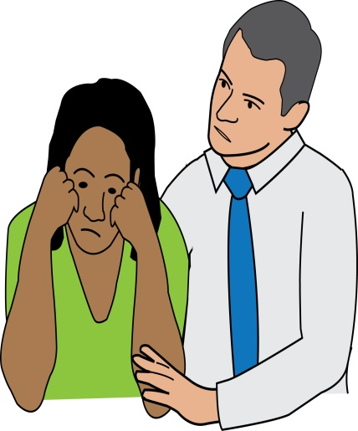
- People with schizophrenia: this is a mental illness where the link between what a person thinks, feels and does, breaks down.
- People with depression: this affects a person’s mood, they can feel very sad and upset and not interested in things. It affects how a person feels, thinks and what a person does.
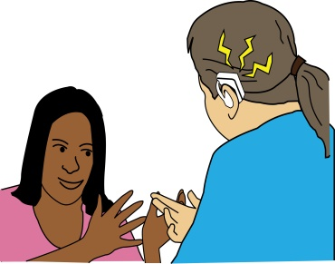
- People with HIV: this is a disease that stops a person’s body from being able to fight infections or illnesses.
- People with sensory impairments
Sensory impairment: these affect a person’s senses, like touch, smell, being able to see and hear.

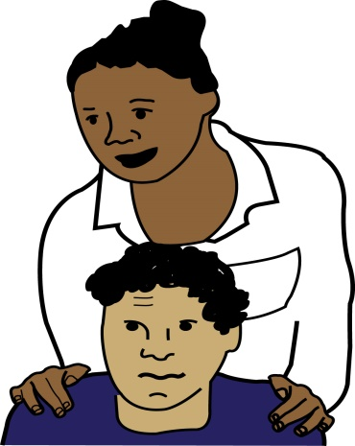
- People with learning difficulties
- People who have had a stroke: this is when blood cannot get to the brain. It can lead to parts of the brain not working and can affect how people can move or speak.
- People who have cancer
- People who have facial disfigurement
Facial disfigurement: this is where the shape or parts of a person’s face change. This can happen when a person is born, if they are part of an accident or because of an illness.

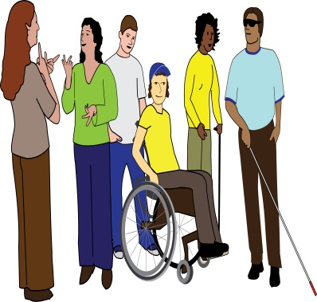
- People who use wheelchairs or walking frames
- People who have personal assistants or carers: these people support Disabled people to get rid of barriers

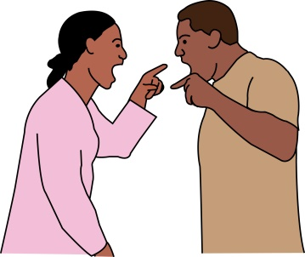
Examples of Disabled Refugees
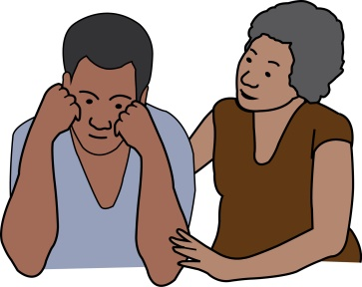
Some people that have been hurt or attacked by people in their country may have a physical impairment. They may also have mental health support needs because of this attack.
People that have had to move to another country sometimes have Post-Traumatic Stress Disorder, depression and other mental health support needs.
Post-Traumatic Stress Disorder: this is when a person has mental health support needs after they have been a part of or seen something shocking or very upsetting. It can affect how well a person sleeps and memories of what happened can keep coming back to them as if it were happening in real life.

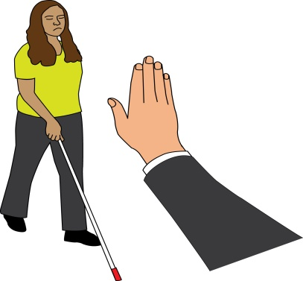
Some people leave their country and go to another country because they are being attacked for being disabled.

General Practitioners (GPs) and Primary Care
General Practitioners or GPs: these are doctors who give treatment to people who are not well.
Primary Care: these are the healthcare services given by the National Health Service. They are the first point of contact. Some examples of these services are: GP’s, dentists that look at a person’s teeth, community pharmacies where people go to get the medication they need or optometrists that look at a person’s eyes.

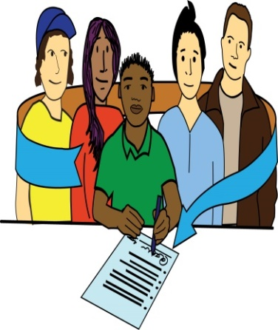
Everyone in the UK can sign up to and go to a local GP. They can get free treatment and can be passed on the other professionals when needed. This is for everyone, even people who have come to the end of trying to live in the UK because the Government has made a final decision.

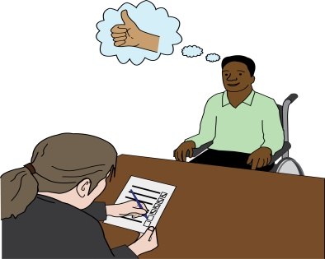
Everyone also means people who are told that they have ‘No recourse to Public Funds’ and refused asylum seekers.
No Recourse to Public Funds: this is part of the law around refugees and asylum seekers that says that some people cannot access some welfare benefits.
Refused Asylum Seeker: this is when a person has tried all of the different ways of staying in the UK and they have been told that they are not allowed. A lot of the time when this happens, it then means that a person cannot access some welfare benefits.

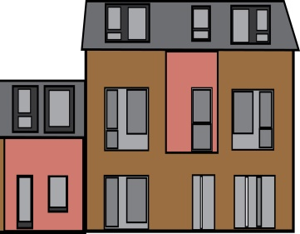
Being able to sign up to a GP usually means that you need to live in the area that the GP works in. A GP can ask you to show where you live, but they cannot keep on asking.
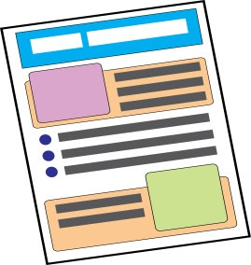
The organisation Doctors of the World have very good information about the healthcare rights that people have in England that can be seen in the link below:
https://www.doctorsoftheworld.org.uk/files/EntitlementToHealthcare20161.pdf

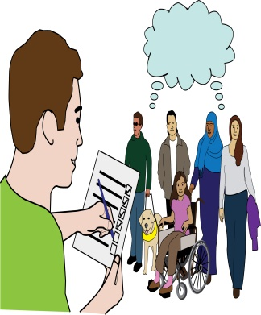
Doctors of the World support people to get appointments and sign up to GPs. They also do research about the barriers that there are for people when signing up to a GP and how this affects them. You can read about this research in the link below:
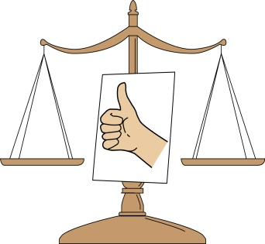
https://www.doctorsoftheworld.org.uk/files/RegistrationRefusedReport_Mar-Oct2015.pdf
Accessing and paying for all of these services is the same for asylum seekers, refugees and ‘refused asylum seekers’ as for all other people that live in the UK.

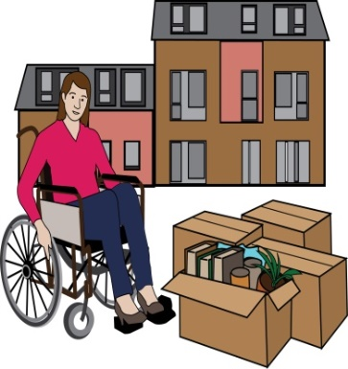
What happens when you live in places for just a short time or when you are homeless?
People that do not have a home or people that are moved around into different homes can sign up to a GP. They are signed up as temporary patients for up to 3 months. f a GP does not let a person sign up, they have two weeks to tell them why.
Temporary patient: this is when a person is signed up to a GP for a short time, less than 3 months.

Hospitals and Secondary Care
Secondary Care: this is care that is given to help a person get better. A person usually uses secondary care after they have been passed on by their GP. Some examples are community health services, mental health services and learning disability services.

Accident and Emergency in hospitals is free for everyone in the UK. There are some services that everyone can use but that some people might have to pay for, such as:
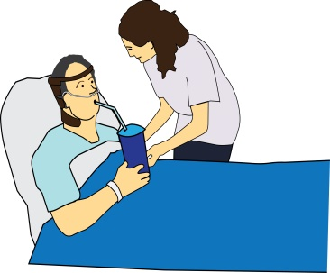
- Staying in a hospital
- When you are passed on to a specialist or another hospital, this can be called a referral
- Secondary Care
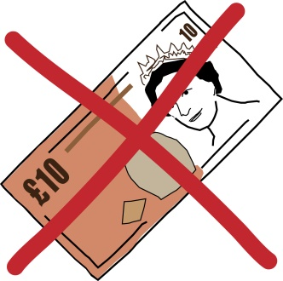
There are a number of groups that are seen as at risk and they do not have to pay for these services. One of the groups that do not have the pay is asylum seekers and refugees.
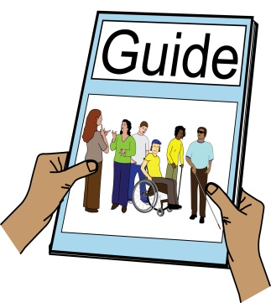
For people that have ‘No recourse to public funds’ it is more difficult to understand. However, most people with a health issue can get free secondary care. Public Health England has a guide to Primary and Secondary Care.
It gives information about the amount of money that different groups of people have to pay for their care. It also has information about the law for asylum seekers and refugees and people with ‘No recourse to public funds’ with health needs:
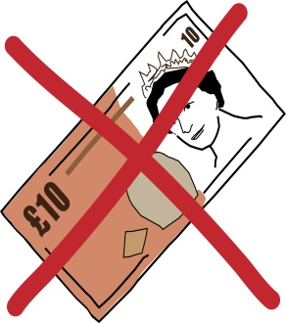
https://www.gov.uk/guidance/nhs-entitlements-migrant-health-guide
Any refused asylum seeker does not have to pay for any treatment that already started before they were told that they could not stay in the UK.
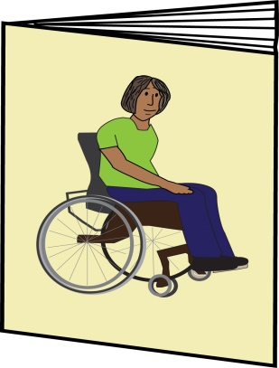
As well as this there are a number of groups that can get secondary care for free:
- People that come under section 4(2) of the Immigration Act, such as people where their physical or mental health means that they cannot go home. Below is a factsheet with more information about this from the Asylum Support Appeals Project:
http://www.asaproject.org/uploads/Factsheet-2-section-4-support.pdf
They also have other useful factsheets:
http://www.asaproject.org/resources
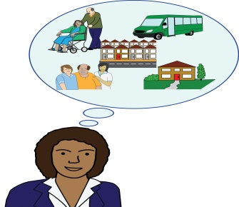
- People that can get Local Authority support or use social services under part 1 of the Care Act 2014
- In Scotland and Wales all asylum seekers and refugees do not have to pay for healthcare or medication

Charges for Healthcare
Refugees and Asylum Seekers do not have to pay for Secondary Care. This means that people that are trying to stay in the UK can get healthcare without worrying about having to pay. Information about this can be seen on page 9 of the Doctors of the World Report below:
https://issuu.com/medecinsdumonde/docs/uk_report_final_2015?e=1803522/35227417

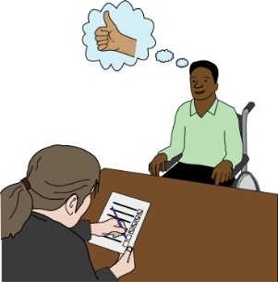
Social Care
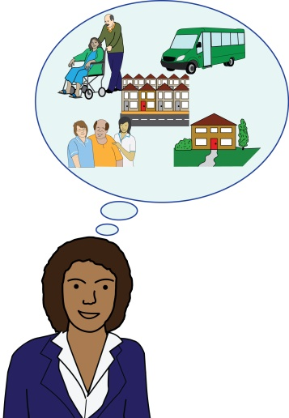
The Care Act 2014 is a law about social care and it says that local authorities must do an assessment of adults who might need care and support. This is for everyone living in the UK; it doesn’t matter if they are an asylum seeker or refugee.
The Care Act means that many people can get support, such as:
- People with mental health needs
- People who have had a stroke
- People with learning difficulties
- People with mobility impairments
Mobility impairment: this is when a person finds it hard to get around and go out and about.

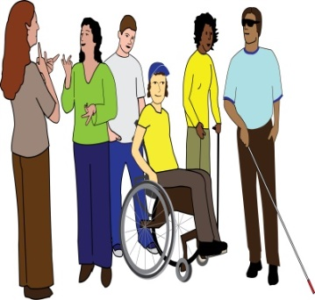
- People with sensory impairments
- People with HIV
- People who have cancer

- People who have multiple sclerosis: this is a disease that gets worse over time and damages parts of the body and the way that it works. It can affects how a person can move, how a person can speak, how a person can see and it can make a person tired.
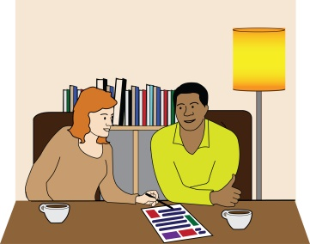
- People who have cerebral palsy: this can affect a person’s muscles and the way that a person can move. In many cases it comes with other impairments.
If a person is found to have care and support needs by the local authority then the local authority must make sure that the person gets the support that they need.
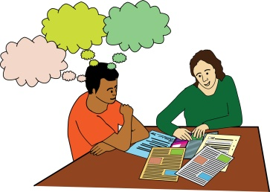
A written copy of the assessment and the decision about support should be given to the person. Local Authorities must also give independent advocacy so that people can talk about their needs.
Independent advocacy: this type of service makes sure that people can get and use their rights, have a stronger voice and have as much control as possible. Being independent means that the advocacy service is not linked to any person or organisation that is part of the person’s local authority care and support decision.

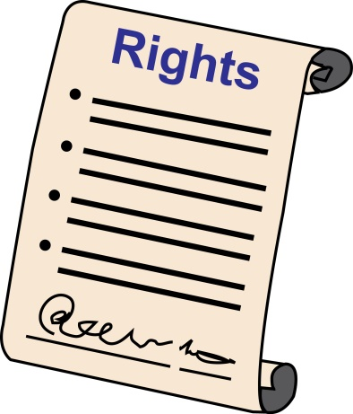
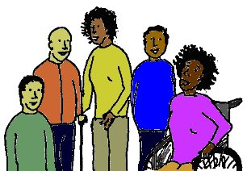
Your local Deaf and Disabled People’s Organisation, or Age UK for older people, can help you. Deaf and Disabled People’s Organisations are run by and for Disabled people.
They can tell you how your Local Authority uses the law and help you to get ready for assessments. Inclusion London has a list of Deaf and Disabled People’s Organisations that can help people access their rights:
https://www.inclusionlondon.org.uk/directory/listing/

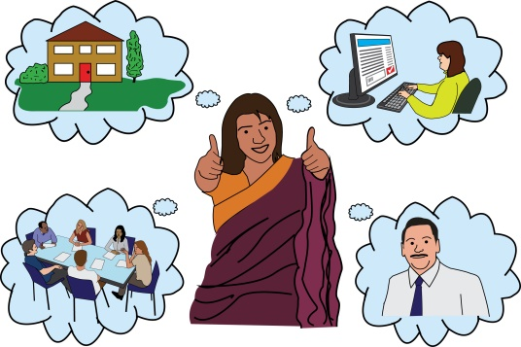
In the Care Act there are examples of what can be given to meet a person’s needs, these are:
- A place to live
- Care and support at home
- Care and support in the community
- Counselling and social work
- Things that a person might need
- Places that a person might need to go to
- Advocacy
Counselling: this is when a person gets support to talk about issues and experiences going on in their lives.

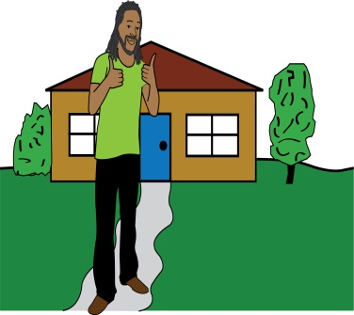
When a person wants to get an assessment by their Local Authority they must show that they live in that area most of the time. They may be asked to show that they live in the area or asked what their link to that area is.
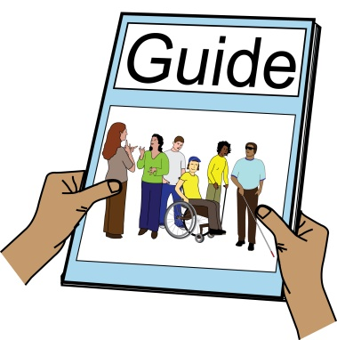
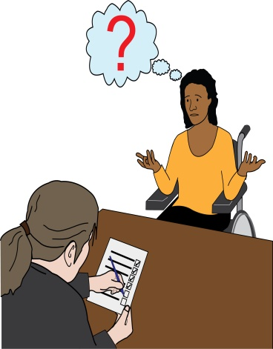
Refused Asylum Seekers cannot get support if their health needs come about because they have been told that they can no longer stay in the UK. If the health needs came about before they were told that they have to leave the UK then they should have an assessment by the Local Authority in the same way as everyone else living in the UK.
The No Recourse to Public Funds Network has a lot of information for people with No Recourse to Public Funds. This can be read about in the link to the guide below:
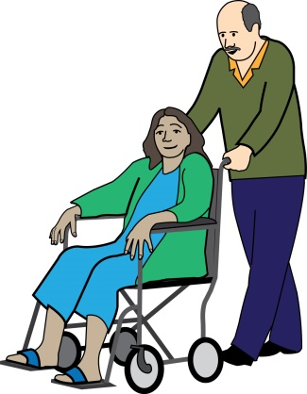
http://www.nrpfnetwork.org.uk/Documents/Practice-Guidance-Adults-England.pdf
The Care Act says that carers and personal assistants with No Recourse to Public Funds should also have an assessment. However, they are not able to get the Carers Allowance, this is money that carers can get when they look after someone for 35 hours or more each week.
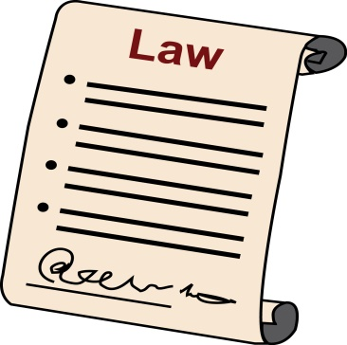
An Example of how the Care Act has been used:
In the UK, case law is used. This means that laws and how they are used are decided by cases that have already been agreed on.
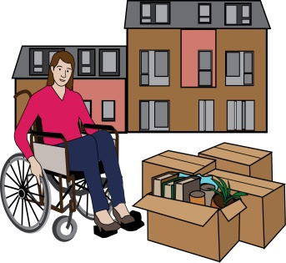
In Haringey an asylum seeker who had been hurt back in her country had mental health and physical health problems. Her lawyer said that under the Care Act, Haringey council must give her a place to live.
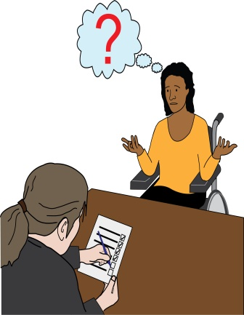
When this went to court, the judge found that her assessment needed to be done again for two reasons. One, she did not have an independent advocate and two, a place to live had not been thought about in her assessment. A new assessment is now being done.
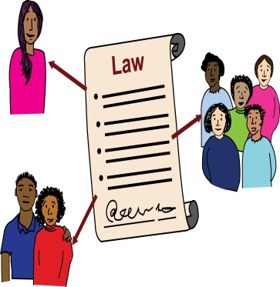
This case sets an example in law of what a local authority must do for people, even when they are an Asylum Seeker. When needed the Local Authority must give a person a place to live and other support. They must also give independent advocacy when needed so that a person can have a fair assessment.
Disabled People’s Rights
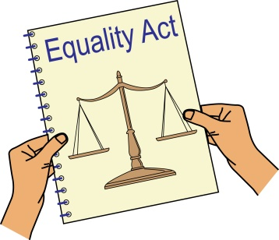
The Equality Act 2010 keeps Disabled people safe from discrimination. It also means that reasonable adjustments must be made to support disabled people with the barriers that they face.
Reasonable adjustments: this is when changes must be made to get rid of barriers and make something or somewhere accessible to a disabled person. This is to make sure that disabled people get the same services as non-disabled people.

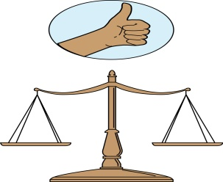
The Equality Act 2010 calls this a duty to make reasonable adjustment. More information can be found about this in the link below:
https://www.citizensadvice.org.uk/discrimination/what-are-the-different-types-of-discrimination/duty-to-make-reasonable-adjustments-for-disabled-people/
Duty: here, this means something that someone must do by law.

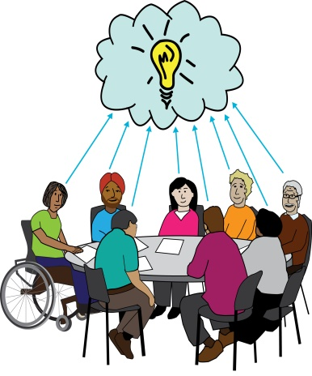
When an adjustment needs to be made, the type of adjustment that is made is usually decided by how much it will cost. These changes are meant to be anticipatory, but it can help to give organisations some ideas about how they can make the changes needed and meet their duty.
Anticipatory: here, this means that organisations need to think about how to get rid of barriers for disabled people before a disabled person uses the service.

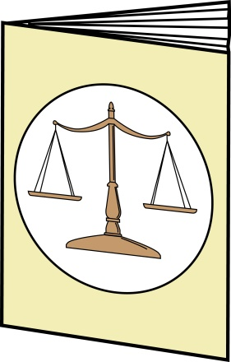
More information can be found about this in the link below:
https://www.equalityhumanrights.com/en/multipage-guide/using-service-reasonable-adjustments-disabled-people

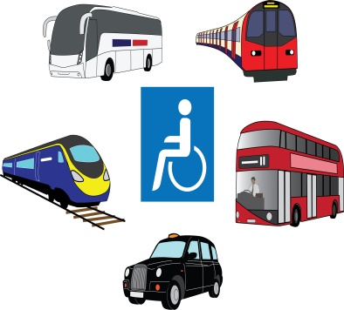
Disabled and older people can also get free or cheaper travel from their local authorities and the organisations that run transport services. There is more information about this on the HEAR website:
https://hearequality.org.uk/policy-and-campaigns-project/disabled-asylum-seekers-and-refugees/
Every Local Authority has different rules about who can get support from the Local Authority and who cannot. In some Local Authorities people with mental health support needs can get transport support, but in others they cannot.
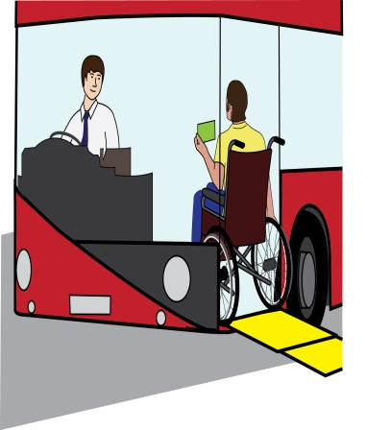
However cheaper travel must be given to all people with sensory impairments, mobility issues and learning difficulties no matter whether they are an Asylum Seeker, a Refugee or not. This is written about in a piece of law called the Transport Act.

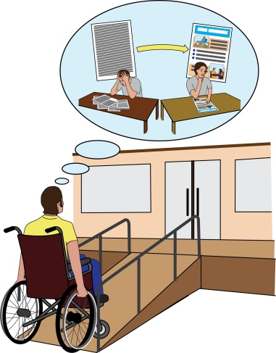
Examples of Reasonable Adjustments
- For wheelchair users, a lift, ramp or
step-free meeting place to get rid of the stair barrier

- Getting a personal assistant, note taker or recording information for someone with dyslexia
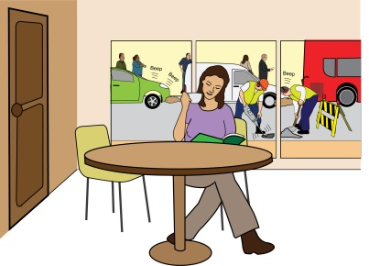
- Plain English information, a quiet space or an advocate for someone with depression
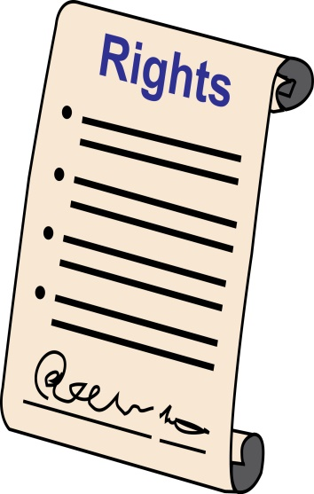
Summary
- This document is not meant as legal advice. It has been written to point out some of the rights that disabled refugees, asylum seekers and people with No Recourse to Public Funds have in the UK. It has also been written to point out some of the mistakes that are made by people and organisations about these rights.
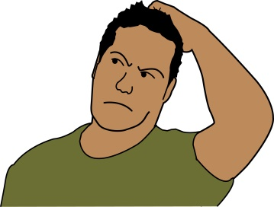
- The law about who can come into and stay in the UK is very difficult to understand and it is always best to get expert advice.
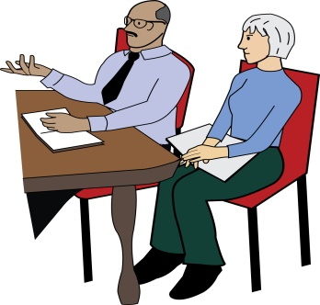
- Ask for an interpreter to help you to access health services. Using family and friends as interpreters means that you can’t keep things private and can cause upset and pain.
Interpreter: this is someone who translates a conversation or spoken words.

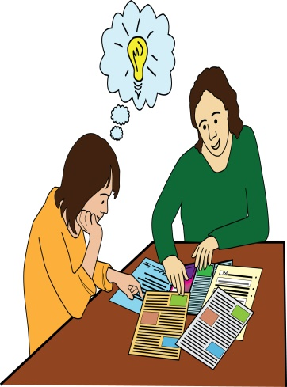
- Ask for an independent advocate or a peer advocate. Deaf and Disabled People’s Organisations usually know local advocates and sign language interpreters.
- Health and social care is getting harder to access, but you can try and get decisions changed.
Peer advocate: this is where a person going through something can get support from someone who has experience of the same thing.

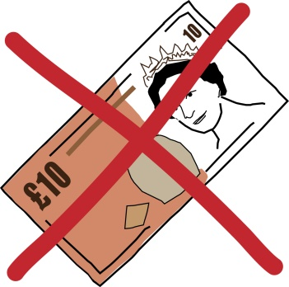
The information below is not for Scotland or Wales where asylum seekers and refugees never pay for healthcare:
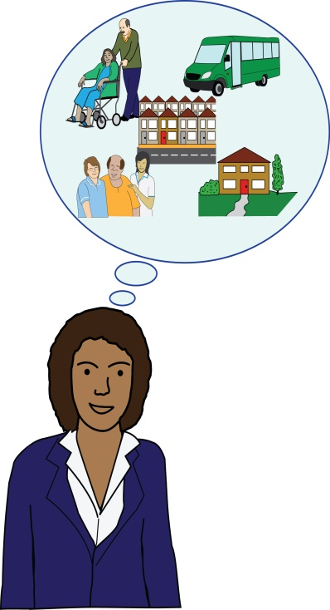
- Asylum seekers, refugees and people who are not allowed to stay in the country and have No Recourse of Public Funds can still use the services below in the same way as anyone else living in the UK:

- GP
- Hospital Accident and Emergency
- Family Planning: this is where people look at having children or not having children
- Cheaper travel for disabled people
- Reasonable Adjustments
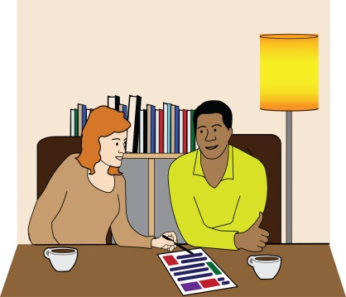
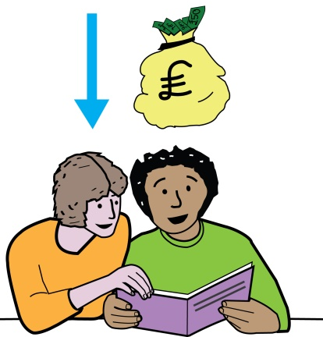
- Refugees and asylum seekers can use the services below in the same way as anyone else living in the UK. However people who can no longer stay in the UK and have No Recourse to Public Funds must pay for the services below:

- Being passed on to other professionals in a hospital when it is not an emergency
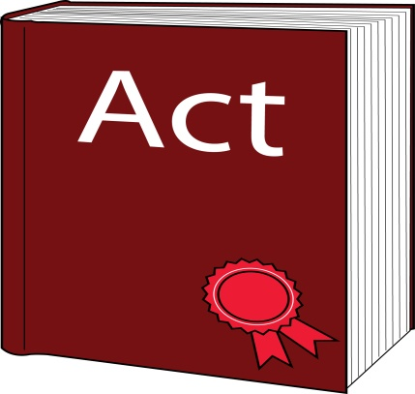
- Rehabilitative Care: this is care that can help people to get better
- Community Mental Health
The only reason that they may not have to pay for the services is they are given support under the Care Act.
- Refugees and asylum seekers can use the services below in the same way as anyone else living in the UK. However people who can no longer stay in the UK and have No Recourse to Public Funds may have to pay for these services.

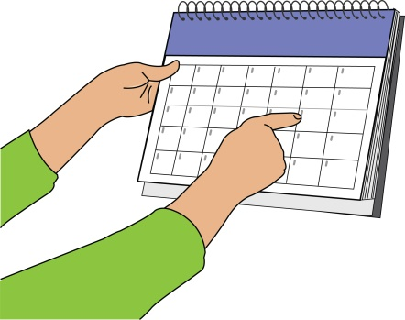
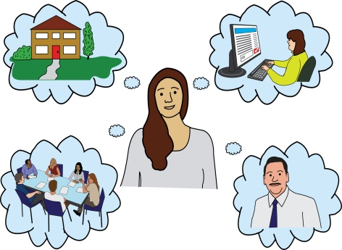
If their health needs come about because they have been told that they can no longer stay in the UK then they must pay. If there health needs start before this then they do not have to pay for the services below:
- Social Services
- Direct Payments/Personalisation: these are benefits that people get, they can choose how they spend the money to meet their care and support needs
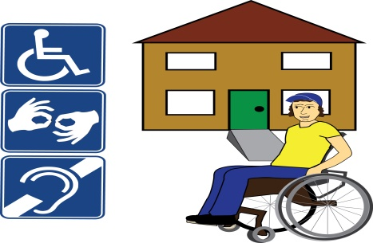
- Adaptations to property: these are changes that people can make to the place that they live to make it accessible.

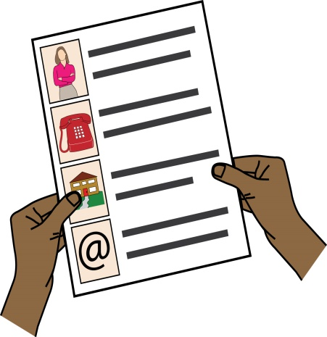
Get in touch with HEAR by emailing HEARcampaigns@reap.org.uk for updates, alternative formats and information about our members’ work. You can also go to our website at: www.HEARequality.org.uk

October 2016

In the Equality Act 2010 a disabled person is said to be a person who has a physical or mental impairment. The impairment has a big effect on the way that a person can do normal day to day things (https://www.gov.uk/definition-of-disability-under-equality-act-2010). The Social Model of Disability says that people with impairments are disabled by the barriers in society. These barriers mean that they are left out of society and discriminated against (https://www.inclusionlondon.org.uk/disability-in-london/social-model/the-social-model-of-disability-and-the-cultural-model-of-deafness/). Disabled People’s Organisations and campaigners use the Social Model of Disability.
http://www.legislation.gov.uk/ukpga/2014/23/contents/enacted/data.htm
www.wilsonllp.co.uk

