A guide to the rights and entitlements of disabled
asylum seekers, refugees and refused applicants in the UK

People with depression and PTSD are Disabled People
Everyone in the UK can register with a GP
Local Authorities should provide accommodation for asylum seekers with care needs

There is a duty to provide ‘reasonable adjustments’ to all Disabled People

Free and concessionary transport helps people attend appointments and reduce isolation

Refugees and Asylum Seekers are exempt from healthcare charges

Social Care support might be counselling or property adaptions

Get appropriate independent or peer advocacy to help access rights

Like Children’s Law, protections for disabled people ‘trump’ immigration law!

 |  | 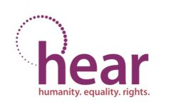 | 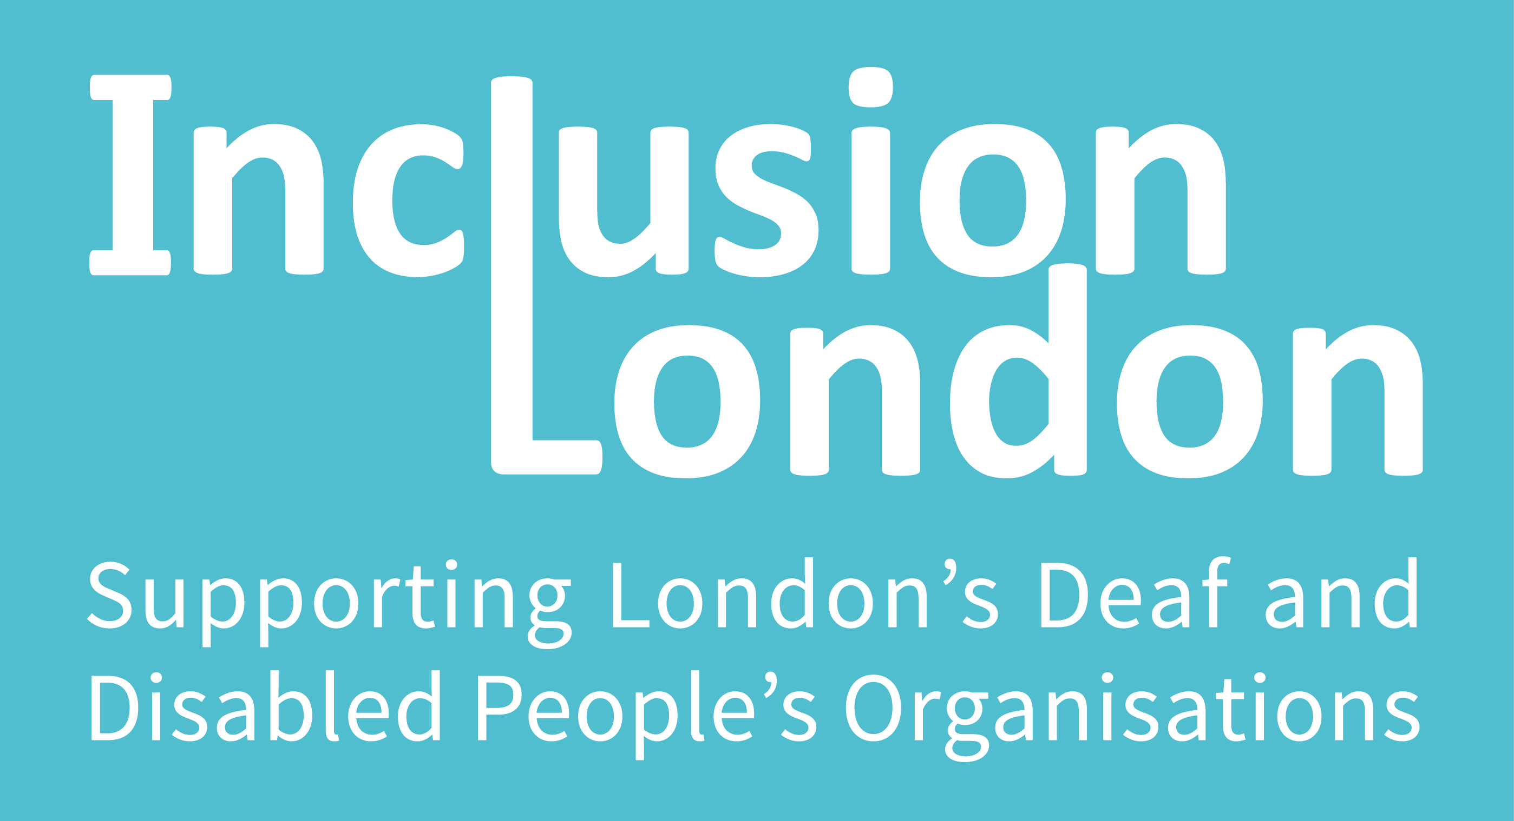 | 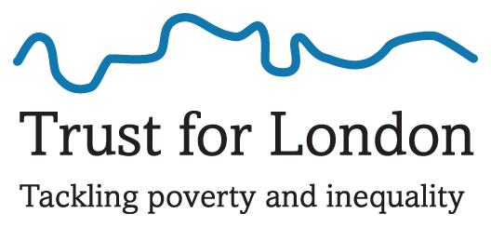 | 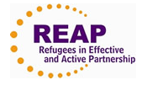
HEAR is the network of equality and human rights organisations
and community groups in London
HEAR Equality and Human Rights Network. Charity number 168591
Disabled Asylum Seekers and Refugees
Asylum seekers and refugees (AS&R) sometimes do not get the right or timely support for physical impairments and mental health needs.
Some service providers and AS&R assume they are not entitled to support because of their immigration status. This is not the case.

Many refugees are “disabled people”. This gives them additional rights and entitlements. Disabled people include people with schizophrenia, depression, HIV, sensory impairments and learning difficulties, survivors of stroke, cancer and facial disfigurement and people who use wheelchairs, walking frames and PAs/carers.
Examples of Disabled Refugees
Survivors of torture, persecution and conflict often have physical and mental health support needs as a result of trauma.
People living in exile often have PTSD, depression and other mental health support needs.
Some people seek asylum because they have been persecuted for being disabled.

General Practitioners (GPs) and Primary Care
GPs and other National Health Service (NHS) support including dentists, community pharmacies and optometrists, are called Primary Care. Everyone in the UK can register with a local GP, and get free treatment and referrals, regardless of immigration status. This also includes people who have reached the end of the immigration process and currently have ‘No Recourse to Public Funds’ (NRPF), or ‘refused asylum seekers’.

Registering with a GP practice usually depends on being resident in the practice boundary. A GP practice can ask for proof of residency or ID, but they cannot insist on it. Doctors of the World have excellent guidance available in ‘Healthcare Entitlement in England’.
Access to and charges for all these primary services is the same for asylum seekers, refugees and ‘refused asylum seekers’ as for other UK citizens.
What about temporary accommodation and homelessness?
GP practices register people that are homeless, dispersed or in temporary accommodation as temporary patients for up to three months.
If a GP practice refuses a patient’s registration they must inform them why within two weeks.
Hospitals and Secondary Care
Accident and Emergency (A&E) in hospitals is free for everyone in UK. Hospital stays and non-emergency referrals to hospitals and specialists, or Secondary Care, can be accessed by anyone in the UK, regardless of immigration status but they may be charged. Secondary Care includes rehabilitative care, community health services, mental health services and learning disability services. A number of vulnerable groups are exempt from charges, including AS&R.
For NRPF in England it is more complicated, but many with health conditions are entitled to free secondary care. Public Health England have detailed guidance for Primary and Secondary Care in ‘NHS Entitlements, Migrant Health Guide’.
Any refused asylum seeker can continue with any course of treatment already underway for free. People under section 4(2) of the Immigration Act (ASAP Factsheet), including people whose physical or mental health means they cannot return home and people eligible to Local Authority care or social services support (under part 1 of the Care Act 2014) are also entitled to free secondary care. In Scotland and Wales all AS&R, including NRPF, are exempt from charges for healthcare and prescriptions.
Charges for Healthcare
Refugees and Asylum Seekers are exempt from charges for Secondary Care.
This means that people in the asylum process can access this healthcare without concerns about being charged.
(casework example, p9, Doctors of the World)
Social Care
The Care Act 2014 means Local Authorities have a duty to assess the needs of adults who appear to require care and support who are ‘ordinarily resident’, regardless of immigration status.
People entitled to support under the Care Act include many people with long-term health conditions; those with mental health service needs, stroke survivors, people with learning difficulties and mobility and sensory impairments, people with HIV, cancer, multiple sclerosis and palsy.
If assessed as having a need the Local Authority has an obligation to provide or fund appropriate support.
A copy of the assessment and decision should be given to the individual in writing. Local Authorities must also provide independent advocacy so people can explain their needs.
Your local Deaf and Disabled People’s Organisation (DDPO/ DPO), or AgeUK for older people, can explain how your Local Authority applies the law and prepare for assessments. Inclusion London have a list of DPOs to help people access entitlements.
In the Care Act examples of what can be provided to meet care needs are accommodation, care and support at home or in the community, counselling and social work, goods, facilities, and advocacy.

Similar to registering with a GP, to be eligible for assessment a person must be ‘ordinarily resident’ in the Local Authority area, and may be asked to prove their connection to the area.
Refused Asylum Seekers are not entitled to support if their health needs are due to them becoming destitute after their application was refused. Otherwise Refused Asylum Seekers should be assessed and supported under the Care Act in the same way as other UK citizens (NRPF Network guidance). NRPF carers/PAs should also be assessed on need, under the Care Act, although they are not entitled to Carers Allowance.
Care Act Case Law Example
“An asylum-seeker and survivor of torture… She has significant mental health and physical health problems. [Wilson’s] argued that LB Haringey had a duty to accommodate her under the Care Act 2014… On 4 August 2015, Mr John Bowers QC, sitting as Deputy Judge of the High Court, quashed LB Haringey’s assessment of SG’s needs under the Care Act 2014, on the grounds that the assessment was conducted without an independent advocate and that it had not adequately considered the possibility of a duty to provide accommodation to meet SG’s needs. A new assessment is now underway” www.wilsonllp.co.uk
This case sets a precedent for LA to provide housing and other support to people without immigration status and to provide independent advocacy to enable assessment of need.
Disabled People’s Rights
The Equality Act 2010 protects disabled people from discrimination and creates a duty to make ‘reasonable adjustments’ to help disabled people overcome barriers.
Whether an adjustment is ‘reasonable’ is usually decided by cost, and whilst the duty to make ‘reasonable adjustments’ is ‘anticipatory’, it can help to suggest a few alternatives to help organisations meet their duty.
Disabled and older people are also entitled to free and concessionary travel from their Local Authorities and public transport providers (HEAR briefing available on website). Every Local Authority has different eligibility (some include mental health service users and others) but concessionary transport must be provided to all people with sensory impairments, mobility issues and learning difficulties regardless of immigration status under the Transport Act.
Examples of Reasonable Adjustments
‘Reasonable adjustments’ can include a lift, ramp or step-free meeting place to overcome the barrier stairs for wheelchair users, the provision of a PA, notetaker or recording for someone with dyslexia, plain English information, a quiet space or an advocate for someone with depression.

Glossary, Summary and Highlights
- This document is not meant as legal advice. Instead it highlights some rights, entitlements and misconceptions about disabled refugees, asylum seekers and NRPF in the UK.
- Immigration law is complex; always get specialist advice.
- Ask for an interpreter in your community language to help access health services. Relying on family/ friends to translate breaches privacy and can cause trauma.
- Ask for an independent or peer advocate. DDPOs usually know local advocates and sign language interpreters.
- Health and social care has become harder for everyone to access, but decisions can be challenged.
- The table below is not for Scotland or Wales where AS&R are never charged for healthcare.
Service in England  =same as for UK citizen | Asylum Seeker | Refugee | Refused/ NRPF
GP
Hospital A&E
Family Planning
Concessionary travel for disabled people
Reasonable Adjustments
Non-emergency hospital referrals |  |  | Cost unless Care Act (Sec 1) or Sec 4(2) then
Rehabilitative Care
Community Mental Health
Social Services |  |  | Not if unwell from destitution otherwise
Direct Payments/Personalisation
Adaptations to Property

An Asylum Seeker is “a person who has left their country of origin and formally applied for asylum in another country but whose application has not yet been concluded” (Refugee Council) Someone an application for asylum with the Home Office, including appeals.
A Refugee “in the UK, a person is officially a refugee when they have their claim for asylum accepted by the government” (Refugee Council) this includes Refugee Status, Indefinite Leave to Remain and Humanitarian Protection This is the definition used in the document and predominately used for accessing rights and entitlements. A Refugee under the Refugee Convention, and used by many NGOS for people at all stages of the asylum process, is “a person who owing to a well-founded fear of being persecuted for reasons of race, religion, nationality, membership of a particular social group or political opinion, is outside the country of his nationality and is unable or, owing to such fear, is unwilling to avail himself of the protection of that country; or who, not having a nationality and being outside the country of his former habitual residence as a result of such events, is unable or, owing to such fear, is unwilling to return to it.” (UNHCR)
AS&R is an acronym for Asylum Seekers and Refugees
A Disabled Person in the Equality Act 2010 is someone who has “a physical or mental impairment that has a ‘substantial’ and ‘long-term’ negative effect on your ability to do normal daily activities” (Definition of disability under the Equality Act 2010, GOV.UK ). Disabled People using “the Social Model of Disability holds that people with impairments are ‘disabled’ by the barriers operating in society that exclude and discriminate against them” (Inclusion London) Disabled People’s Organisations and campaigners use this definition.
PAs or Personal Assistants, sometimes known as carers are people who support disabled individuals overcome specific barriers.
No Recourse to Public Funds, or NRPF, is someone subject to immigration control and has no entitlement to certain welfare benefits.
A refused asylum seeker refers to someone whose application for asylum has been refused by the UK authorities and has exhausted all rights of appeal. Often resulting as a person having ‘No Recourse to Public Funds’ (NRPF).
‘Healthcare Entitlement in England’ Doctors of the World. DOTW also offers appointments, support GP registration and research the impact and barriers to GP registration. ‘Registration refused: A study on access to GP registration in England’ Doctors of the World.
Public Health England, NHS Entitlements, Migrant Health Guide 2014 outlines exemptions under National Health Service (Charges to Overseas Visitors) Regulations 2015 as well as other legislation for AS&R and NRPF with health needs
ASAP or Asylum Support Appeals Project has useful factsheets on section 4(2) and section 9 etc.
Deaf and Disabled Peoples Organisations (DDPO), or Disabled Peoples Organisation (DPO) are run by disabled people for disabled people. List of London DPOs from Inclusion London
The NRPF Network has detailed information for people with No Recourse to Public Funds in Practice Guidance for Local Authorities (England) Assessing and Supporting Adults who have No Recourse to Public Funds (NRPF ), 2016
Reasonable adjustments for disabled people are when “employers, shops, local authorities and schools must take positive steps to remove the barriers you face... This is to ensure you receive the same services, as far as this is possible, as someone who's not disabled. The Equality Act 2010 calls this the duty to make reasonable adjustment” (Citizens’ Advice Bureau)
The duty is ‘anticipatory’. This means an organisation they should think in advance (and on an ongoing basis) about what disabled people with a range of impairments might need to overcome barriers (Equality and Human Rights Commission) Contact HEARcampaigns@reap.org.uk for updates, alternative formats and details of our members’ work or see www.hearequality.org.uk October 2016

